7/1/2026
David John

GOPHISH
PHISHING AWARENESS CAMPAIGN

Table of Contents
1. Introduction 3
2. Objectives 3
3. Prerequisites 4
3.1 Hardware Requirements 4
3.2 Software Requirements 5
3.3 Working Environment 5
3.4 Network Configuration 6
3.5 Prior Knowledge 6
3.6 Assumptions 7
3.7 Ethical and Legal Considerations 7
Step 1: Create an Email Template 9
Objective 9
Email Template Configuration 10
Step 2: Create the Landing Page 14
Objective 14
Why is a Landing Page Necessary? 14
Landing Page Configuration 15
Capturing Submitted Data 17
Relationship Between the Email and Landing Page 18
Redirect URL 18
Step 3: Creating the Sending Profile 19
Objective 19
Sending Profile Components 20
Configuring Google App Passwords 21
Mailpit SMTP Configuration 22
Step 4: Creating Users and Groups 24
Objective 24
Step 5: Creating the Phishing Campaign 26
Objective 26
Campaign Configuration 26
Campaign Name 26
Email Template 26
Landing Page 27
Users and Groups 27
Sending Profile 27
Campaign URL 28
Gmail SMTP Testing 28
Expected Output 30
a) Email template 30
b) landing page 31
c) redirect page 32
Monitoring Results 33
a. Dashboards 33
b. Results timeline 34

1. Introduction
Phishing remains one of the most common cybersecurity threats affecting organisations today. Attackers often exploit human trust through deceptive emails and fake websites to steal sensitive information such as usernames, passwords, and other confidential data. As phishing attacks continue to evolve, many organisations have adopted phishing simulation exercises to evaluate how users respond to suspicious emails and to strengthen cybersecurity awareness through practical training.
This implementation guide documents the deployment and configuration of a phishing simulation campaign using GoPhish, an open-source phishing framework. The project was built around a fictitious AI Agent Pilot Program, where selected employees received an invitation to participate in an organisational AI initiative. During the implementation, I configured a realistic phishing email template, a credential collection landing page, recipient groups, sending profiles, and campaign settings to simulate how a phishing attack could be carried out within a controlled environment.
To support the implementation, two SMTP delivery methods were evaluated. Google SMTP was configured to send phishing emails through a Gmail account, while Mailpit, running inside a Docker container, was used as a local SMTP server for testing. The implementation also demonstrates how GoPhish can monitor campaign performance by tracking email delivery, email opens, link clicks, and credentials submitted during the simulation. These results help demonstrate how organisations can measure user awareness and identify areas where additional security training may be required.
The entire implementation was carried out in an isolated Kali Linux virtual machine running on Oracle VirtualBox. This environment ensured that all phishing activities remained contained and suitable for testing, demonstration, and cybersecurity awareness purposes without affecting production systems.

2. Objectives
The primary objective of this implementation guide is to demonstrate the end-to-end deployment of a phishing simulation campaign using GoPhish within a controlled environment.
The specific objectives are to:
- Demonstrate the installation and configuration of the GoPhish phishing simulation framework.
- Configure both Google SMTP and Mailpit SMTP for phishing email delivery and compare their suitability for different deployment scenarios.
- Design and implement a realistic phishing email template based on an organizational AI Agent Pilot Program invitation.
- Develop a phishing landing page capable of capturing submitted credentials within an authorized testing environment.
- Configure recipient groups, sending profiles, landing pages, and campaign settings required for launching a phishing simulation.
- Deploy and execute a phishing campaign while monitoring recipient interactions throughout the phishing lifecycle.
- Demonstrate GoPhish's reporting capabilities by analyzing campaign metrics, including email delivery, email opens, link clicks, and submitted credentials.
- Redirect participants to a security awareness page after form submission to reinforce phishing awareness and cybersecurity best practices.
- Provide a practical implementation guide that can be used for cybersecurity awareness training, demonstrations, and authorized phishing simulation exercises.

3. Prerequisites
Before implementing the phishing simulation campaign, several hardware, software, and networking requirements must be satisfied. In addition, users following this guide should possess basic knowledge of Linux administration, networking, and phishing simulation concepts. These prerequisites ensure that the implementation process proceeds smoothly and that the phishing campaign can be deployed and tested successfully within an isolated environment.

3.1 Hardware Requirements
The implementation was carried out on a virtualized environment running Kali Linux inside Oracle VirtualBox. The minimum hardware requirements are shown in Table 3.1.
Component | Requirement
Host Computer | Desktop or Laptop Computer
Processor | Intel/AMD processor with virtualization support (VT-x/AMD-V enabled)
Memory (RAM) | Minimum 8 GB (16 GB recommended)
Storage | At least 40 GB of available disk space
Internet Connection | Required for package installation and Google SMTP connectivity

3.2 Software Requirements
The software listed in Table 3.2 was used throughout the implementation.
Software | Purpose
Oracle VirtualBox | Hosts the Kali Linux virtual machine
Kali Linux | Operating system used to deploy GoPhish
GoPhish | Phishing simulation framework
Docker | Containerization platform used for Mailpit
Mailpit | Local SMTP server used during testing
Python 3 | Hosts the phishing awareness page after credential submission
Mozilla Firefox / Google Chrome | Accessing the GoPhish administration interface and testing campaigns
Google Gmail Account | Used as the SMTP email service for sending phishing emails

3.3 Working Environment
The phishing simulation was developed within an isolated virtual environment to prevent interference with production systems and to provide a safe environment for testing.
The implementation environment consisted of:
Component | Configuration
Host Operating System | Microsoft Windows
Virtualization Platform | Oracle VirtualBox
Guest Operating System | Kali Linux
Phishing Framework | GoPhish
Email Delivery Service | Google SMTP
Testing SMTP Server | Mailpit (Docker)
Awareness Page Hosting | Python HTTP Server
Programming Languages | HTML and CSS
Web Browser | Mozilla Firefox

This configuration provided a controlled environment for developing, testing, and demonstrating the phishing simulation while maintaining isolation from the host operating system.

3.4 Network Configuration
Two virtual network adapters were configured within VirtualBox to support internet connectivity and communication between the host machine and the Kali Linux virtual machine.
Virtual Adapter | Purpose
Adapter 1 (NAT) | Provides internet connectivity to the Kali Linux virtual machine. This connection was required for downloading software packages and sending phishing emails through Google SMTP.
Adapter 2 (Host-Only Adapter) | Enables communication between the Windows host machine and the Kali Linux virtual machine for accessing locally hosted GoPhish services and the phishing awareness page.

The Host-Only Adapter was assigned the IP address:
192.168.56.101
This IP address was used to access the phishing landing page, GoPhish services, and the awareness page hosted on the Kali Linux virtual machine.

3.5 Prior Knowledge
Before attempting this implementation, the reader should possess a basic understanding of the following concepts:
- Linux operating system fundamentals and command-line usage.
- Virtual machine creation and management using Oracle VirtualBox.
- Basic networking concepts including IP addressing, ports, DNS, and SMTP.
- HTML and CSS for creating email templates and phishing landing pages.
- Docker fundamentals for container deployment.
- Phishing attack techniques and cybersecurity awareness concepts.
- Basic administration of the GoPhish phishing simulation framework.
Possessing this knowledge enables readers to understand the purpose of each configuration step and troubleshoot common implementation issues.

3.6 Assumptions
This implementation assumes that:
- Oracle VirtualBox has already been installed on the host computer.
- Kali Linux has been successfully installed and configured as a virtual machine.
- GoPhish has been installed and is operational.
- The user has administrative privileges on the Kali Linux virtual machine.
- Internet connectivity is available for configuring Google SMTP and downloading required software packages.
- A Gmail account has been configured with an App Password for SMTP authentication.
- The phishing simulation is conducted within an authorized environment with prior approval from the relevant organizational stakeholders.
- The phishing campaign is intended solely for cybersecurity awareness, testing, and educational purposes.

3.7 Ethical and Legal Considerations
Phishing simulation tools play an important role in improving cybersecurity awareness by evaluating user susceptibility to phishing attacks within controlled environments. Because these tools are capable of imitating legitimate emails and credential collection pages, they must only be used with proper authorization.
The implementation described in this guide was conducted in a controlled laboratory environment and was intended solely for educational, testing, and cybersecurity awareness purposes. Any deployment of phishing simulations within an organizational environment should be approved by the organization's management and Information Security or Security Operations Centre (SOC). Collected campaign data should be handled confidentially and used exclusively to improve security awareness and organizational resilience against phishing attacks.

GoPhish Component | Purpose | Your Google SMTP Setup | Your Mailpit Setup
Email Template | Defines the email content | Same | Same
Landing Page | Page users visit after clicking | Same | Same
Groups | Defines recipients | Same | Same
Sending Profile | Defines how emails are sent | Gmail SMTP | Mailpit SMTP
Campaign | Combines everything into a simulation | Different URL | Different URL

Step 1: Create an Email Template

Objective
The first step in creating a phishing campaign is to design the email that will be delivered to the target users.
In GoPhish, the email template defines:
- the sender's display information,
- the subject line,
- the email body,
- and any dynamic placeholders that will be customized for each recipient.
Without an email template, there is no message for the campaign to send.

Why is an Email Template Necessary?
The email template serves as the first point of interaction between the phishing campaign and the recipient.
Its purpose is to:
- capture the recipient's attention,
- appear believable,
- encourage the recipient to click the embedded link,
- direct the recipient to the configured landing page.
From a cybersecurity awareness perspective, this is the component that evaluates whether users can identify suspicious emails before interacting with them.

The Scenario
For this simulation, I created a scenario in which the organization was introducing a new AI-powered assistant through an AI Agent Pilot Program. Selected employees received an invitation informing them that they had been chosen to participate in the pilot before its official rollout. Rather than relying on urgency or fear, the campaign was designed around curiosity, exclusivity, professional relevance, and perceived legitimacy. The objective was to evaluate whether recipients would verify the unexpected invitation before interacting with the embedded link.

Email Template Configuration
Sender
One of your Gmail accounts was configured as the sender.
The recipient would therefore see something similar to:
From:
Your Name <yourgmail@gmail.com>
Why this field matters
The sender's identity plays an important role in how recipients judge the legitimacy of an email. In real phishing attacks, attackers often impersonate trusted individuals or departments to increase the likelihood that recipients will engage with the message. In this simulation, I used my Gmail account and configured it to send emails through Google's SMTP service. In a real organisational assessment, this would normally be replaced with an authorized corporate email address or domain.

Subject
Invitation to join the AI Agent Pilot Program
Why this subject?
A subject line is one of the first elements a recipient notices.
This particular subject was designed to:
- sound official,
- generate curiosity,
- imply exclusivity,
- avoid creating unnecessary alarm.
It encourages engagement without appearing overly suspicious.

Email Body
<html>
<head>
<title>AI Agent Pilot Program Invitation</title>
</head>
<body>
<p>Hello {{.FirstName}},</p>

<p>You have been selected to participate in the <strong>AI Agent Pilot Program</strong>. As one of our pilot users, you will have early access to explore and evaluate our new AI assistant before its organization-wide rollout.</p>

<p>To activate your access, please click the link below:</p>

<p><a href="{{.URL}}">Activate My AI Pilot Access</a></p>

<p>If you have any questions regarding this pilot program, please contact the AI Innovation Team.</p>

<p>Regards,<br />
AI Innovation Team</p>

<p>{{.Tracker}}</p>
</body>
</html>.

{{.FirstName}}
This is a GoPhish template variable.
Instead of every recipient seeing:
Hello User
each person receives a personalized greeting.
For example:
Hello Alice
or
Hello John
GoPhish automatically replaces this placeholder with the First Name stored for each user in the selected recipient group.
Why use it?
Personalization increases credibility. Recipients are generally more likely to trust emails addressed directly to them than generic messages.

{{.URL}}
This placeholder is automatically replaced by GoPhish with a unique tracking URL generated for each recipient.
For example, while the template contains:
{{.URL}}
an individual recipient might receive a link such as:
http://your-phishing-server/?rid=K2xP8L
Each recipient receives a different identifier, allowing GoPhish to associate clicks with specific users.
Why use it?
This enables the platform to record who clicked the link without requiring recipients to manually identify themselves.

{{.Tracker}}
This inserts GoPhish's tracking image into the email.
If the recipient's email client loads remote images, GoPhish records that the email was opened.
Why use it?
It allows the campaign to distinguish between recipients who merely received the email and those who actually opened it, providing an additional metric for the awareness assessment.

How this Email Supports the Campaign
The email was intentionally kept short, professional, and believable. Instead of overwhelming recipients with unnecessary information, it presented a realistic invitation that encouraged them to interact with the embedded link. By combining a personalised greeting, a professional subject line, and an invitation to join an AI initiative, the campaign simulated a situation that employees could realistically encounter in a workplace environment.
Google SMTP vs. Mailpit at This Stage
Although two different SMTP services were evaluated during this implementation, the email template itself remained unchanged. Whether the campaign was delivered through Google SMTP or Mailpit, the same template was used. The only difference was the sending profile configured later in the implementation, while the content and structure of the email remained identical.

Step 2: Create the Landing Page

Objective
Once a recipient clicks the link contained in the phishing email, they are redirected to a landing page. This page represents the second stage of the phishing simulation and continues the scenario introduced in the email. For this implementation, I designed the landing page as the AI Agent Pilot Program Enrolment Portal, where selected employees were asked to verify their organisational identity before activating access to the pilot programme.

Why is a Landing Page Necessary?
The phishing email alone can only determine whether a recipient:
- received the email,
- opened it,
- or clicked the embedded link.
However, a phishing attack rarely ends with a click.
Most phishing campaigns aim to persuade users to perform a second action, such as:
- logging into a portal,
- entering credentials,
- submitting personal information,
- downloading a document,
- or authorizing an application.
The landing page therefore measures a deeper level of user interaction by evaluating whether recipients continue to trust the website after clicking the email. This provides a more accurate indication of user awareness than simply measuring email opens or link clicks.
The interaction flow is illustrated below.
Phishing Email
Recipient Opens Email
Recipient Clicks Link
Landing Page Displayed
`
User Enters Information
Form Submitted
GoPhish Records the Event

Landing Page Scenario
To maintain consistency throughout the simulation, the landing page continued the same AI Agent Pilot Program scenario introduced in the email. Rather than requesting credentials without explanation, the page informed users that they needed to verify their organisational identity before their pilot access could be activated. Maintaining the same storyline from the email to the landing page made the simulation more realistic and reflected techniques commonly used in real phishing campaigns, where attackers present a consistent narrative to gain the victim's trust.

Landing Page Configuration
When creating the landing page in GoPhish, the following configuration options were considered.
a. Landing Page Name
The landing page was assigned a descriptive internal name, for example:
AI Agent Pilot Program Landing Page
This name exists solely for administration within GoPhish and is not visible to recipients.

b. HTML Content
The landing page consisted of a professionally styled HTML document that simulated an internal organizational portal.
The page contained:
- a program title,
- introductory information,
- a brief explanation of the AI pilot initiative,
- a login form requesting organizational credentials,
- an activation button,
- an internal system notice.
Unlike the email template, the landing page was designed as a complete web page using HTML and CSS to resemble an authentic internal application.

c. User Interface Design
The landing page was intentionally designed using a clean and minimal corporate style.
Major design elements included:
- centered login card
- white content panel
- subtle shadow effects
- blue corporate colour theme
- clearly labelled input fields
- single activation button
The layout closely resembles many internal enterprise applications, reducing unnecessary suspicion while remaining simple enough for educational purposes.

d. Credential Verification Form
Unlike the initial boilerplate page, which only contained an activation button, the final implementation included a login form.
The form requested:
- Organizational Email Address
- Password
followed by an Activate My Access button.
This design was selected because it naturally fits the campaign narrative.
Rather than requesting credentials without explanation, the page states that organizational identity must be verified before access to the AI Agent Pilot Program can be activated.
From the recipient's perspective, this appears to be a logical continuation of the enrollment process initiated through the email invitation.

Capturing Submitted Data
One of the objectives of the simulation was to evaluate GoPhish's ability to record user interactions after the landing page had been reached.
GoPhish provides an option to Capture Submitted Data, allowing the platform to record information entered into HTML form fields.
When enabled, GoPhish records submitted values for analysis after the campaign concludes.
This allows security teams to understand not only who interacted with the phishing email, but also how far each participant progressed through the simulation before recognising—or failing to recognise—the phishing attempt.
Capturing Passwords
For testing purposes, the landing page also included a password field.
GoPhish provides a separate option labelled Capture Passwords, which records password field submissions when explicitly enabled.
This functionality was implemented solely within an authorized internal laboratory environment for demonstration and validation purposes.
In real organizational phishing awareness campaigns, whether password values are captured depends on organizational policy, legal requirements, and the scope of the approved assessment. Many organizations choose to record only that a password field was submitted without storing the actual password.
Redirect Behaviour
After a user submits the login form, GoPhish can redirect them to another webpage. This provides a more natural ending to the phishing simulation and allows organisations to immediately provide feedback or awareness training instead of leaving participants on the credential submission page.
A redirect may be configured to:
- the organization's homepage,
- an awareness notification,
- an internal portal,
- or another authorized destination.
Redirecting users provides a more natural conclusion to the simulation and avoids leaving participants on an unfinished webpage.

Relationship Between the Email and Landing Page
The landing page is directly linked to the phishing email through the GoPhish placeholder:
<a href="{{.URL}}">
Activate My AI Pilot Access
</a>
When a recipient clicks this hyperlink:
- GoPhish identifies the intended recipient using the unique tracking identifier embedded within the URL.
- The platform records that the recipient clicked the phishing link.
- The configured landing page is presented to the recipient.
- If the user submits the login form, GoPhish records the submission according to the configured capture settings.
- The user may then be redirected to the configured destination.
This integration allows GoPhish to reconstruct the complete sequence of user interactions throughout the phishing campaign.

Redirect URL
Once the login form has been submitted, GoPhish can redirect the participant to another webpage using the Redirect URL setting. In this implementation, the redirect was configured to display a dedicated Security Awareness page. Rather than leaving users on the credential submission page, they were immediately presented with information explaining that they had participated in a simulated phishing exercise together with guidance on recognizing and responding to phishing attacks.
The redirect serves two primary purposes:
- to provide a natural conclusion to the phishing simulation;
- to educate participants after they have interacted with the phishing page.
For this project, the redirect destination was configured to display a Security Awareness page informing participants that they had successfully identified—or fallen victim to—a simulated phishing exercise.
Rather than leaving users on the credential submission page, the browser was redirected to an independently hosted HTML page containing awareness information and recommended cybersecurity practices.

Awareness Page
The awareness page was developed as a standalone HTML document and hosted using Python's lightweight HTTP server on the Kali Linux virtual machine.
The page informed participants that:
- the email formed part of an authorized phishing awareness exercise;
- the AI Agent Pilot Program invitation was simulated;
- phishing attacks frequently exploit trust and curiosity to obtain sensitive information;
- users should verify email senders, inspect hyperlinks before clicking, and report suspicious emails to the Security Operations Centre (SOC).
Providing immediate feedback transformed the simulation into a practical learning experience rather than simply measuring user behaviour.

Step 3: Creating the Sending Profile

Objective
The Sending Profile determines how GoPhish delivers phishing emails to recipients. While the email template defines what recipients see, the Sending Profile contains the SMTP configuration required to send the emails successfully. During this implementation, I configured two separate Sending Profiles: Google SMTP, which was used to send emails to real recipients during controlled testing, and Mailpit SMTP, which was used for local development and testing without transmitting emails over the Internet. Using both configurations allowed the phishing campaign to be tested safely before validating the complete workflow.For this project, two separate Sending Profiles were configured:
- Google SMTP – used to deliver phishing emails to real email accounts for controlled testing.
- Mailpit SMTP – used as a local SMTP server during development and testing without sending emails over the Internet.
This dual configuration enabled both safe local testing and end-to-end validation of the phishing campaign.

Sending Profile Components
Profile Name
Each Sending Profile contains the information GoPhish requires to communicate with an SMTP server. Although the configuration differs depending on the mail service being used, the same core settings are required to establish a successful connection and deliver phishing emails.
Example:
Google SMTP
or
Mailpit SMTP
The profile name is visible only within GoPhish and is not displayed to email recipients.

Interface Type
The interface type was configured as:
SMTP
SMTP (Simple Mail Transfer Protocol) is the standard protocol used to send email between mail servers and client applications. GoPhish uses this protocol to communicate with the configured mail server and deliver phishing emails to recipients.

Sender Email Address
The sender email address determines the email account from which phishing emails appear to originate.
For the Google SMTP configuration, a personal Gmail account was used for testing purposes.
Example:
example@gmail.com
This address appeared in the From field of emails received by participants.

Google SMTP Configuration
To enable GoPhish to send emails through Gmail, the following SMTP server settings were configured.
Setting | Value
Interface Type | SMTP
Host | smtp.gmail.com:587
Username | Personal Gmail Address
Password | Google App Password
Ignore Certificate Errors | Enabled
Email Headers | Not Configured
The SMTP host:
smtp.gmail.com:587
specifies Google's outgoing mail server and TCP port 587, which supports authenticated SMTP communication using TLS encryption.
The username consisted of the Gmail address used to authenticate with Google's SMTP service.
Instead of using the Google account password directly, a dedicated Google App Password was configured for authentication.
No additional email headers were configured, as the default headers generated by GoPhish were sufficient for the phishing simulation.

Configuring Google App Passwords
Google no longer permits many third-party applications to authenticate to Gmail using the account's primary password. Instead, an App Password must be generated after enabling Two-Step Verification.
The following steps were used to generate the App Password used by GoPhish:
- Sign in to the Google Account that will be used for sending emails.
- Open Google Account Settings.
- Navigate to Security.
- Enable 2-Step Verification (if not already enabled).
- Return to the Security page and open App Passwords.
- Create a new App Password for GoPhish.
- Copy the generated 16-character password.
- Paste the generated App Password into the Password field of the GoPhish Sending Profile.
The generated App Password allows GoPhish to authenticate securely with Gmail's SMTP server without exposing the primary Google account password.
After completing the phishing exercise, the App Password can be revoked from the Google Account settings if it is no longer required.

Mailpit SMTP Configuration
During development, Mailpit was used as a local SMTP server to test email templates, landing pages, and campaign functionality before sending emails through Gmail. Instead of forwarding emails across the Internet, Mailpit captures them locally, allowing the complete phishing workflow to be tested safely without contacting external recipients.
The following configuration was used.
Setting | Value
Interface Type | SMTP
Host | 127.0.0.1:1025
Username | Not Required
Password | Not Required
Ignore Certificate Errors | Default
Email Headers | Not Configured
Mailpit was deployed using Docker with its default port mappings:
- SMTP Server: TCP Port 1025
- Web Interface: TCP Port 8025
The SMTP server listened on:
127.0.0.1:1025
allowing GoPhish to deliver emails directly to Mailpit.
Captured emails were then viewed through the Mailpit web interface at:
http://127.0.0.1:8025
This configuration allowed repeated testing of phishing emails without sending messages to external recipients.

Google SMTP vs Mailpit
Two different SMTP configurations were implemented to support different stages of the project.
Feature | Google SMTP | Mailpit SMTP
Purpose | Send emails to real recipients | Local testing and development
SMTP Host | smtp.gmail.com:587 | 127.0.0.1:1025
Authentication | Gmail Address + Google App Password | Not Required
Internet Required | Yes | No
Email Delivery | External Recipients | Captured Locally
Web Interface | Gmail | http://127.0.0.1:8025

Using both configurations allowed the phishing campaign to be tested safely during development before validating the complete workflow using Gmail's SMTP service.

Summary
The Sending Profile provided the communication bridge between GoPhish and the configured SMTP server. Two SMTP environments were implemented throughout the project. Mailpit was used during development to safely capture and inspect emails locally, while Google SMTP was used to validate the phishing campaign under realistic conditions by delivering emails to actual recipients. Authentication to Gmail was achieved using a Google App Password, ensuring secure SMTP access without exposing the primary Google account credentials.

Step 4: Creating Users and Groups

Objective
The Users and Groups module in GoPhish is used to define who will receive the phishing emails during a campaign. Instead of selecting individual recipients every time a campaign is created, users are organized into reusable groups. This approach simplifies campaign management, especially when conducting multiple phishing awareness exercises involving the same participants or departments.
Each group represents a collection of recipients who will receive the phishing emails generated during the simulation.

Creating a Group
The first task was to create a recipient group by assigning it a descriptive name that identified the intended audience. For this implementation, the group was named AI Agent Pilot Participants. This name is used only within GoPhish to help administrators identify and select the correct recipients when creating a phishing campaign.
Example:
AI Agent Pilot Participants
The group name serves as an internal identifier within GoPhish and is later selected when creating a phishing campaign.

Adding Users
GoPhish provides two methods for adding recipients to a group:
Manual Entry
Recipients can be entered individually by providing details such as:
- First Name
- Last Name
- Email Address
- Position (Optional)
This method is suitable for small-scale phishing simulations or testing individual email accounts.

Bulk Import
For larger campaigns, GoPhish supports importing multiple recipients simultaneously using a CSV (Comma-Separated Values) file.
A typical CSV file contains columns such as:
- First Name
- Last Name
- Email Address
- Position
Bulk import simplifies recipient management and significantly reduces the time required to prepare large phishing campaigns.

Purpose of Groups
Recipient groups make campaign management more efficient by allowing the same collection of users to be reused across different phishing simulations. Once a group has been created, it can be selected during campaign configuration, and GoPhish automatically sends the phishing emails to every recipient contained within that group. This reduces repetitive configuration and helps maintain consistency across multiple campaigns.

Summary
The Users and Groups module provides a simple and organised way of managing phishing campaign recipients. For this project, a dedicated recipient group was created and populated with user information, allowing the configured email template and sending profile to be distributed efficiently during campaign execution.

Step 5: Creating the Phishing Campaign

Objective
Creating the phishing campaign is the final stage of the GoPhish configuration process. At this point, all previously configured components—including the email template, landing page, sending profile, and recipient group—are brought together into a single campaign. Once launched, GoPhish automatically delivers the phishing emails, tracks recipient interactions, records submitted information where configured, and generates campaign statistics that can be reviewed after the simulation.

Campaign Configuration
The campaign was configured using the settings shown below.
Setting | Configuration
Campaign Name | Phishing Awareness
Email Template | AI Pilot Program Rollout
Landing Page | AI Agent Pilot Enrollment Page
URL | Configured according to the SMTP environment
Users and Groups | AI Agent Pilot Participants
Sending Profile | Internal AI Campaign SMTP
Launch Date | Immediate (Current Date and Time)
Launch By | Left Blank

Campaign Name
The campaign was assigned the name Phishing Awareness, which served as the internal identifier within GoPhish. Assigning a clear and descriptive name makes it easier to distinguish this campaign from future phishing simulations conducted within the platform.

Email Template
The campaign used the previously created AI Pilot Program Rollout email template. During execution, GoPhish automatically personalised each email by replacing template variables such as {{.FirstName}}, {{.URL}}, and {{.Tracker}} with recipient-specific information. This ensured that every participant received a customised email while allowing GoPhish to track individual interactions throughout the campaign.

Landing Page
The AI Agent Pilot Enrolment Page was selected as the landing page for the campaign. After recipients clicked the phishing link, they were directed to this page, where they were asked to verify their organisational identity before activating access to the pilot programme. Where enabled, GoPhish also recorded submitted form data before redirecting participants to the security awareness page.

Users and Groups
The campaign targeted the AI Agent Pilot Participants recipient group created earlier in the implementation. Instead of manually selecting recipients during campaign creation, GoPhish automatically retrieved every user contained within the selected group, making the campaign easier to configure and manage.

Sending Profile
The Sending Profile determines how the phishing emails are delivered to recipients. During this implementation, two different profiles were used depending on the stage of testing. Mailpit provided a safe environment for local development and validation, while Google SMTP was used to verify the complete phishing workflow by delivering emails to real recipients.
Mailpit (Development and Testing)
During development, Mailpit was used to safely validate the phishing campaign without sending emails over the Internet.
The Sending Profile pointed to the local Mailpit SMTP server.
Google SMTP (End-to-End Validation)
After validating the campaign locally, the Sending Profile was changed to the Gmail SMTP configuration to verify the complete phishing workflow using real email delivery.
Changing the Sending Profile required no modifications to the email template, landing page, or campaign configuration.

Campaign URL

The Campaign URL specifies the address recipients are directed to after clicking the phishing link contained in the email. This URL must point to the server hosting the phishing landing page. During this implementation, the same landing page was used for both local testing and Gmail SMTP validation, with only the Sending Profile changing between the two environments.

Mailpit / Local Testing
During local development, the phishing landing page was hosted on the Kali Linux virtual machine using the Host-Only network adapter.
The campaign URL was configured as:
http://192.168.56.101
This allowed devices on the Host-Only network, including the Windows host machine, to access the landing page hosted by GoPhish.

Gmail SMTP Testing
When validating the campaign using Gmail SMTP, the same landing page remained in use.
The campaign URL continued to point to the GoPhish server hosting the landing page:
http://192.168.56.101
The only component that changed between Mailpit and Gmail SMTP was the Sending Profile responsible for delivering the emails.

Launch Date
The Launch Date determines when GoPhish begins sending phishing emails. For this implementation, the campaign was configured to launch immediately using the current system date and time. GoPhish also supports scheduling campaigns to run automatically at a future date when required.
Launch By
The Launch By field was left blank, allowing GoPhish to automatically start the campaign according to the configured launch date without assigning it to a specific administrator.
Campaign Workflow
Once the campaign was launched, GoPhish executed the following sequence of events:
Campaign Launched

Email Template Retrieved

Sending Profile Connects to SMTP Server

Emails Delivered to Recipient Group

Recipient Opens Email

Recipient Clicks Embedded Link

Landing Page Displayed

Credentials Submitted

GoPhish Records Interaction

User Redirected to Security Awareness Page

Expected Output

a) Email template
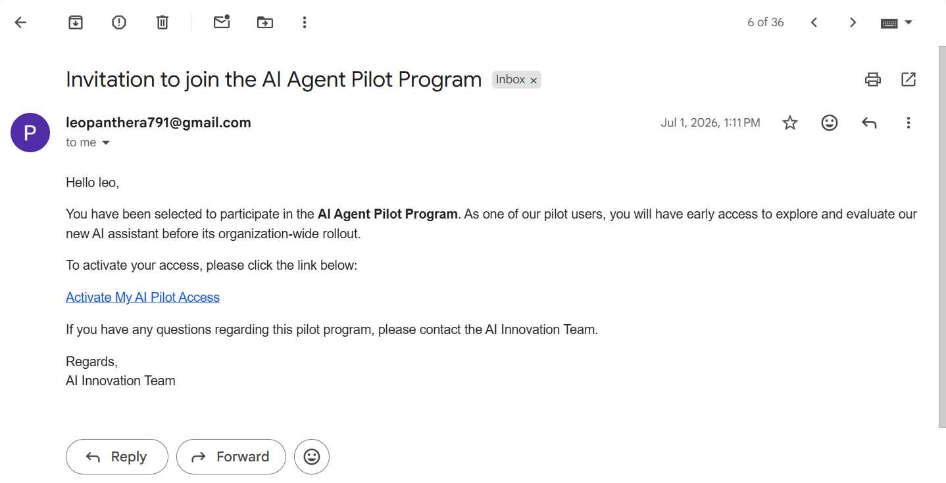

b) landing page
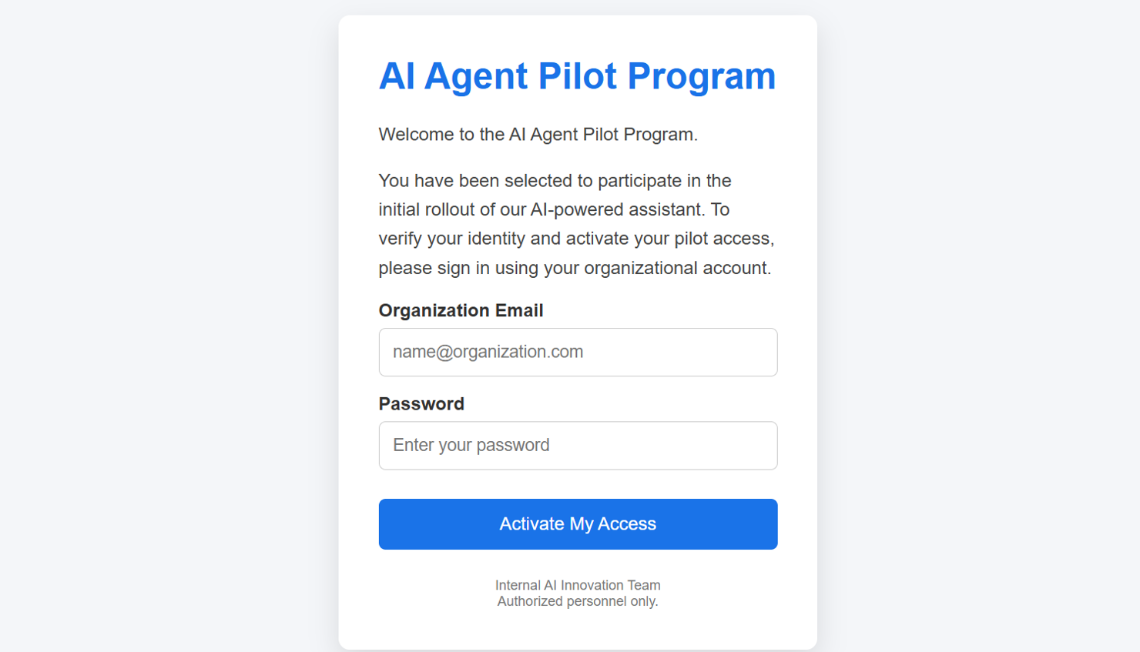

c) redirect page
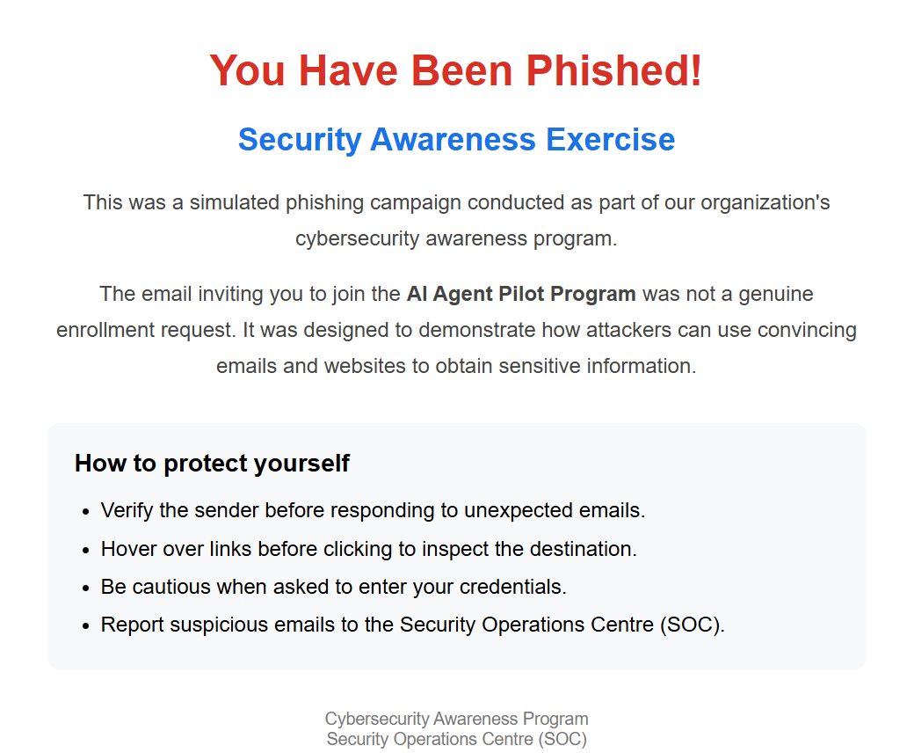

Monitoring Results

a. Dashboards
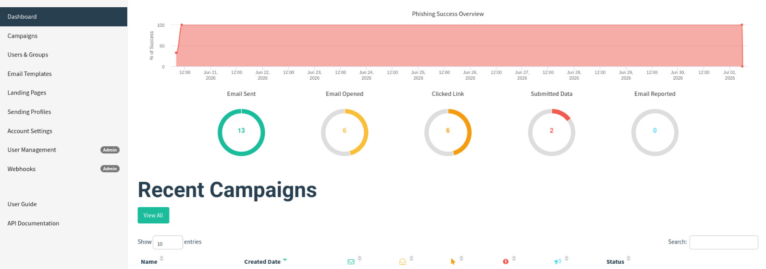

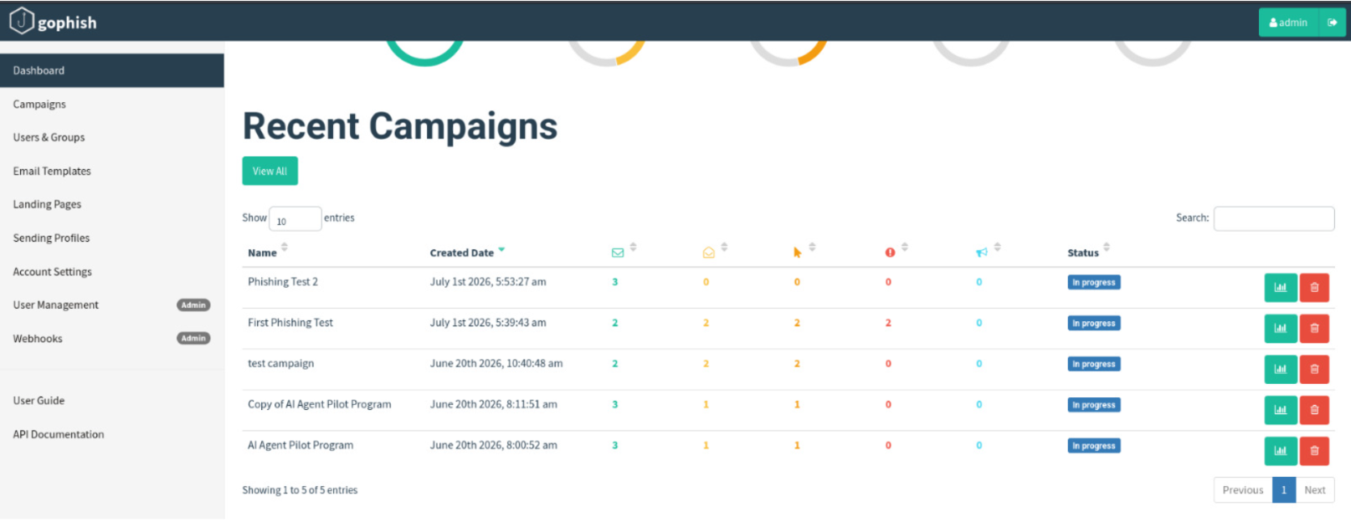

b. Results timeline
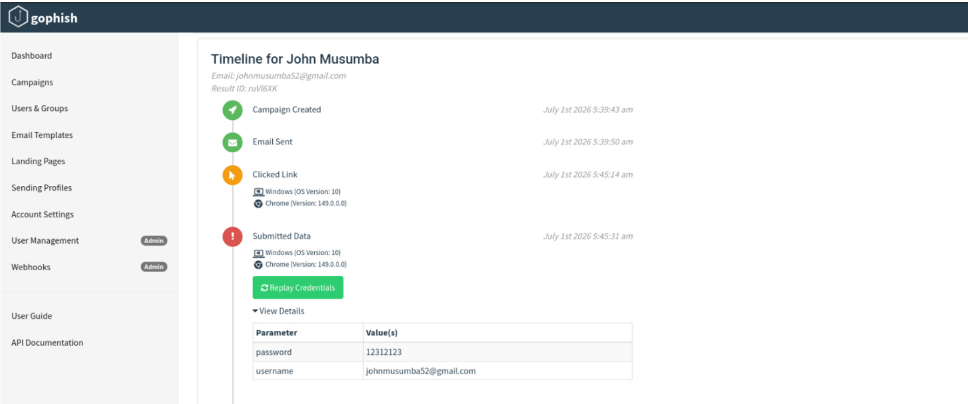

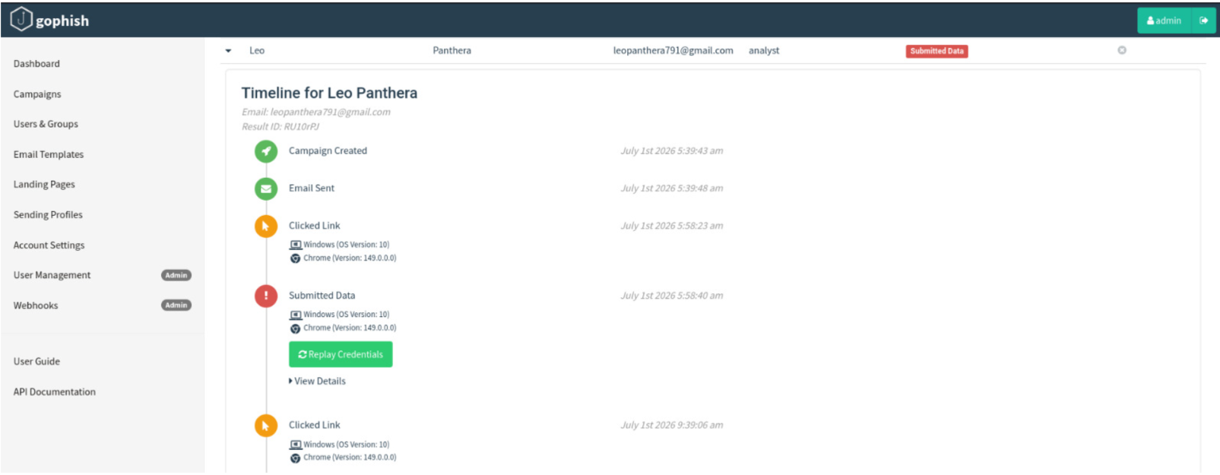
NB: The exercise performed above was entirely a simulation campaign for educational purposes. The accounts highlighted above belong to the user conducting the campaign under a controlled lab environment.
Summary
The campaign creation stage integrated all previously configured GoPhish components into a single phishing awareness exercise. By selecting the appropriate email template, landing page, recipient group, sending profile, and campaign URL, GoPhish was able to automate the complete phishing workflow—from email delivery and interaction tracking to credential submission and post-submission user awareness.

